**TUGAS PRAKTIKUM RPLL**

**Digitalisasi Kartu Kehadiran Seminar**

**Disusun Oleh:**

**Ilham Taufik G651180291**

**Mardiah G651180441**

**Melati Aulia Putri G64150080**



**PROGRAM STUDI ILMU KOMPUTER**

**SEKOLAH PASCASARJANA**

**INSTITUT PERTANIAN BOGOR**

**BOGOR**

**2018**

**BAB I**

**PENDAHULUAN**

**1.1 Latar Belakang**

Seminar hasil adalah salah satu seminar yang dilakukan oleh mahasiswa yang sedang menempuh pendidikan jenjang strata 2 di IPB. Dalam pelaksanaannya, siding ini wajib di hadiri oleh minimal 10 orang peserta.

Peserta diwajibkan membawa kartu kuning saat menghadiri seminar untuk medapatkan tanda tangan moderator sebagai validasi kehadiran. Kartu kuning adalah kartu yang berfungsi sebagai pengesahan bukti kehadiran peserta dalam seminar, lebih dikenal dengan kartu kuning karena kartu bukti kehadiran ini berwarna kuning. Kartu ini berisikan bidang keilmuan, biodata mahasiswa, dan foto. Menjadi peserta yang menghadiri seminar adalah kewajiban bagi mahasiwa pasca sarjana IPB, sedikitnya menghadiri 14 kali seminar di bidang keilmuan sesuai peminatan, dan 4 kali hadir di bidang keilmuan lain yang sudah ada daftarnya di kartu kuning tersebut. Namun dalam pelaksanaannya, audiens yang datang terkadang terlalu ramai dan berdesa-desakan untuk masuk ke ruang seminar, bahkan terkadang audiens dari seminar yang diadakan di jadwal sebelumnya belum keluar ruangan .

Berdasarkan uraian diatas, kami melakukan survey dengan menggunakan kuesioner google form tentang digitalisasi kartu kuning.

**1.2 Tujuan dan Manfaat**

* Mempermudah akses informasi jadwal seminar hasil.
* Memberi informasi kapasitas ruangan, nama ruangan, serta jumlah audiens yang telah mengisi kuota, dan kuota yang tersedia.
* Menertibkan audiens yang menghadiri seminar.

**BAB II**

**HASIL DAN PEMBAHASAN**

**2.1 Survey**

Menurut Masri Singarimbun dalam bukunya yang berjudul Metode Penelitian Survai, pengertian survei pada umumnya dibatasi pada penelitian yang datanya dikumpulkan dari sampel atau populasi untuk mewakili seluruh populasi. Dengan demikian, penelitian survei adalah penelitian yang mengambil sampel dari satu populasi dan menggunakan kuesioner sebagai alat pengumpulan data yang pokok (Singarimbun, 2006).

Berdasarkan latar belakang yang ada, maka kami melakukan survey dengan metode penyebaran kuesioner via *google form*. Dengan responden terdiri dari 34 orang responden dari fakultas FMIPA. Berikut data disajikan dalam grafik dengan presentase.

Pertanyaan pertama dan kedua

1. Apakah pernah mengikuti seminar hasil di SPS IPB?

2. Apakah Anda kesulitan mengetahui informasi jadwal seminar hasil?

Pertanyaan ketiga

3. Jika iya, apa saja kendala yang anda hadapi saat ingin menghadiri seminar hasil?

Pertanyaan keempat

4. Apakah Anda setuju jika kartu kuning diganti dalam bentuk aplikasi mobile?

**2.2 Class Diagram**

Menurut (Whitten & Bentley, 2007, p. 400), *Class diagram* adalah sebuah penggambaran grafis dari sebuah struktur obyek statis pada sistem, yang menunjukkan kelas obyek yang menyusun sistem beserta relasi antara kelas-kelas obyek tersebut.

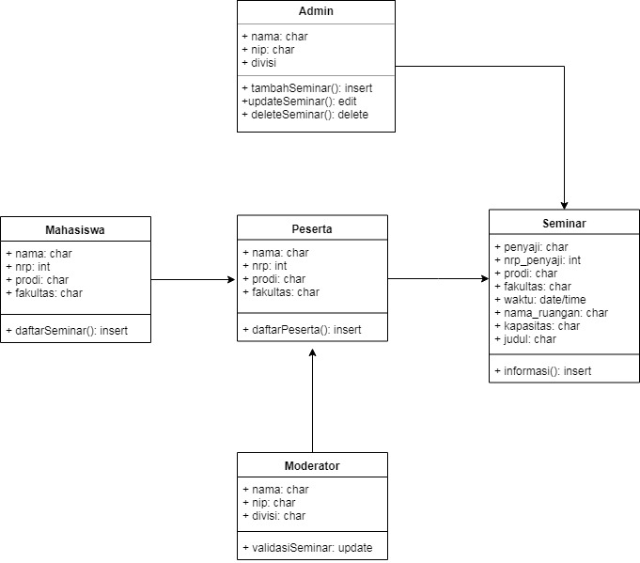

**2.3 *Story Board***

Menurut Cristiano (2005), *Storyboard* adalah sebuah *outline*  atau *draft* dari sebuah produksi berupa gambar - gambar yang beruntun.

Menurut Cristiano (2005), *Storyboard* digunakan untuk mengurangi beban waktu dan biaya bagi sang produser. Bayangkan betapa rumitnya sebuah proyek besar yang tidak terencana, tentu akan mengakibatkan kelangsungan pengerjaan proyek itu akan tersendat atau bahkan mungkin gagal.

**2.4 Use Case**

Menurut (Whitten & Bentley, 2007, p. 246), *Use-case diagram* menggambarkan interaksi-interaksi antara sistem dan sistem eksternal dan pengguna. *Use-case* diagram memiliki komponen yang harus dipenuhi, yaitu :

- *Use Cases*, yaitu sekumpulan fungsi yang terdapat dalam sistem dimana fungsi-fungsi tersebut dapat dilakukan oleh *actor (user)* untuk melakukan pekerjaannya dengan sistem yang ada.

- *Actors*, yaitu segala sesuatu yang menginisiasi sistem, yaitu *use-case,* dengan tujuan menyelesaikan tugas bisnis yang memproduksi suatu nilai yang dapat diukur.

- *Relationships*, yaitu garis yang menghubungkan antara 2 simbol pada *use-case diagram.* Arti dari relasi yang digambarkan bisa berbeda tergantung dari bagaimana garis digambar dan lambang seperti apa yang dipakai untuk menghubungkan.

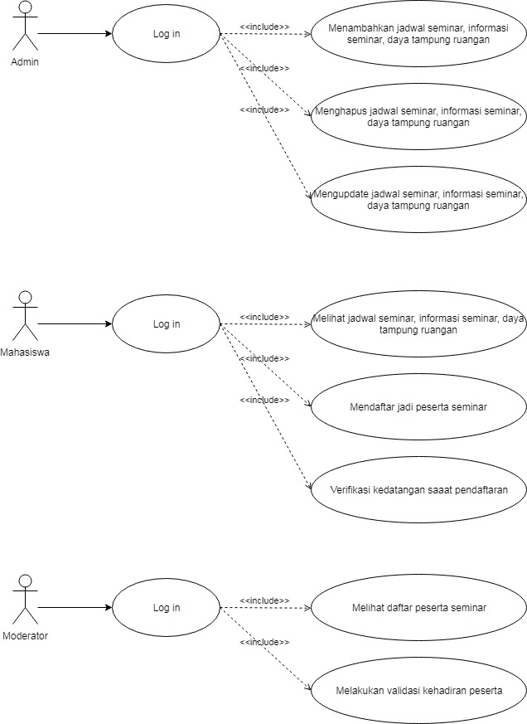

%3CmxGraphModel%3E%3Croot%3E%3CmxCell%20id%3D%220%22%2F%3E%3CmxCell%20id%3D%221%22%20parent%3D%220%22%2F%3E%3CmxCell%20id%3D%222%22%20value%3D%22Admin%26lt%3Bbr%26gt%3B%22%20style%3D%22shape%3DumlActor%3BverticalLabelPosition%3Dbottom%3BlabelBackgroundColor%3D%23ffffff%3BverticalAlign%3Dtop%3Bhtml%3D1%3BoutlineConnect%3D0%3B%22%20vertex%3D%221%22%20parent%3D%221%22%3E%3CmxGeometry%20x%3D%2280%22%20y%3D%2260%22%20width%3D%2230%22%20height%3D%2260%22%20as%3D%22geometry%22%2F%3E%3C%2FmxCell%3E%3CmxCell%20id%3D%223%22%20value%3D%22%22%20style%3D%22endArrow%3Dclassic%3Bhtml%3D1%3BentryX%3D0%3BentryY%3D0.5%3B%22%20edge%3D%221%22%20target%3D%224%22%20parent%3D%221%22%3E%3CmxGeometry%20width%3D%2250%22%20height%3D%2250%22%20relative%3D%221%22%20as%3D%22geometry%22%3E%3CmxPoint%20x%3D%22110%22%20y%3D%22100%22%20as%3D%22sourcePoint%22%2F%3E%3CmxPoint%20x%3D%22240%22%20y%3D%22100%22%20as%3D%22targetPoint%22%2F%3E%3C%2FmxGeometry%3E%3C%2FmxCell%3E%3CmxCell%20id%3D%224%22%20value%3D%22Log%20in%22%20style%3D%22ellipse%3BwhiteSpace%3Dwrap%3Bhtml%3D1%3B%22%20vertex%3D%221%22%20parent%3D%221%22%3E%3CmxGeometry%20x%3D%22200%22%20y%3D%2265%22%20width%3D%22130%22%20height%3D%2270%22%20as%3D%22geometry%22%2F%3E%3C%2FmxCell%3E%3CmxCell%20id%3D%225%22%20value%3D%22Menambahkan%20jadwal%20seminar%2C%20informasi%20seminar%2C%20daya%20tampung%20ruangan%22%20style%3D%22ellipse%3BwhiteSpace%3Dwrap%3Bhtml%3D1%3B%22%20vertex%3D%221%22%20parent%3D%221%22%3E%3CmxGeometry%20x%3D%22440%22%20y%3D%2260%22%20width%3D%22260%22%20height%3D%2280%22%20as%3D%22geometry%22%2F%3E%3C%2FmxCell%3E%3CmxCell%20id%3D%226%22%20value%3D%22Menghapus%20jadwal%20seminar%2C%20informasi%20seminar%2C%20daya%20tampung%20ruangan%22%20style%3D%22ellipse%3BwhiteSpace%3Dwrap%3Bhtml%3D1%3B%22%20vertex%3D%221%22%20parent%3D%221%22%3E%3CmxGeometry%20x%3D%22440%22%20y%3D%22160%22%20width%3D%22260%22%20height%3D%2280%22%20as%3D%22geometry%22%2F%3E%3C%2FmxCell%3E%3CmxCell%20id%3D%227%22%20value%3D%22Mengupdate%20jadwal%20seminar%2C%20informasi%20seminar%2C%20daya%20tampung%20ruangan%22%20style%3D%22ellipse%3BwhiteSpace%3Dwrap%3Bhtml%3D1%3B%22%20vertex%3D%221%22%20parent%3D%221%22%3E%3CmxGeometry%20x%3D%22440%22%20y%3D%22260%22%20width%3D%22260%22%20height%3D%2280%22%20as%3D%22geometry%22%2F%3E%3C%2FmxCell%3E%3CmxCell%20id%3D%228%22%20value%3D%22%26amp%3Blt%3B%26amp%3Blt%3Binclude%26amp%3Bgt%3B%26amp%3Bgt%3B%22%20style%3D%22edgeStyle%3Dnone%3Bhtml%3D1%3BendArrow%3Dopen%3BverticalAlign%3Dbottom%3Bdashed%3D1%3BlabelBackgroundColor%3Dnone%3BexitX%3D1%3BexitY%3D0.5%3B%22%20edge%3D%221%22%20source%3D%224%22%20parent%3D%221%22%3E%3CmxGeometry%20width%3D%22160%22%20relative%3D%221%22%20as%3D%22geometry%22%3E%3CmxPoint%20x%3D%22345.98031926758176%22%20y%3D%22100.02990159633782%22%20as%3D%22sourcePoint%22%2F%3E%3CmxPoint%20x%3D%22440.0028451017404%22%20y%3D%22100.7614612408463%22%20as%3D%22targetPoint%22%2F%3E%3C%2FmxGeometry%3E%3C%2FmxCell%3E%3CmxCell%20id%3D%229%22%20value%3D%22%26amp%3Blt%3B%26amp%3Blt%3Binclude%26amp%3Bgt%3B%26amp%3Bgt%3B%22%20style%3D%22edgeStyle%3Dnone%3Bhtml%3D1%3BendArrow%3Dopen%3BverticalAlign%3Dbottom%3Bdashed%3D1%3BlabelBackgroundColor%3Dnone%3BexitX%3D1%3BexitY%3D0.5%3BentryX%3D0%3BentryY%3D0.5%3B%22%20edge%3D%221%22%20source%3D%224%22%20target%3D%226%22%20parent%3D%221%22%3E%3CmxGeometry%20width%3D%22160%22%20relative%3D%221%22%20as%3D%22geometry%22%3E%3CmxPoint%20x%3D%22340%22%20y%3D%22110%22%20as%3D%22sourcePoint%22%2F%3E%3CmxPoint%20x%3D%22450.0028451017404%22%20y%3D%22110.7614612408463%22%20as%3D%22targetPoint%22%2F%3E%3C%2FmxGeometry%3E%3C%2FmxCell%3E%3CmxCell%20id%3D%2210%22%20value%3D%22%26amp%3Blt%3B%26amp%3Blt%3Binclude%26amp%3Bgt%3B%26amp%3Bgt%3B%22%20style%3D%22edgeStyle%3Dnone%3Bhtml%3D1%3BendArrow%3Dopen%3BverticalAlign%3Dbottom%3Bdashed%3D1%3BlabelBackgroundColor%3Dnone%3BexitX%3D1%3BexitY%3D0.5%3BentryX%3D0%3BentryY%3D0.5%3B%22%20edge%3D%221%22%20source%3D%224%22%20target%3D%227%22%20parent%3D%221%22%3E%3CmxGeometry%20width%3D%22160%22%20relative%3D%221%22%20as%3D%22geometry%22%3E%3CmxPoint%20x%3D%22340%22%20y%3D%22110%22%20as%3D%22sourcePoint%22%2F%3E%3CmxPoint%20x%3D%22460%22%20y%3D%22220%22%20as%3D%22targetPoint%22%2F%3E%3C%2FmxGeometry%3E%3C%2FmxCell%3E%3CmxCell%20id%3D%2211%22%20value%3D%22Mahasiswa%26lt%3Bbr%26gt%3B%22%20style%3D%22shape%3DumlActor%3BverticalLabelPosition%3Dbottom%3BlabelBackgroundColor%3D%23ffffff%3BverticalAlign%3Dtop%3Bhtml%3D1%3BoutlineConnect%3D0%3B%22%20vertex%3D%221%22%20parent%3D%221%22%3E%3CmxGeometry%20x%3D%2280%22%20y%3D%22410%22%20width%3D%2230%22%20height%3D%2260%22%20as%3D%22geometry%22%2F%3E%3C%2FmxCell%3E%3CmxCell%20id%3D%2212%22%20value%3D%22%22%20style%3D%22endArrow%3Dclassic%3Bhtml%3D1%3BentryX%3D0%3BentryY%3D0.5%3B%22%20edge%3D%221%22%20target%3D%2213%22%20parent%3D%221%22%3E%3CmxGeometry%20width%3D%2250%22%20height%3D%2250%22%20relative%3D%221%22%20as%3D%22geometry%22%3E%3CmxPoint%20x%3D%22110%22%20y%3D%22450%22%20as%3D%22sourcePoint%22%2F%3E%3CmxPoint%20x%3D%22240%22%20y%3D%22450%22%20as%3D%22targetPoint%22%2F%3E%3C%2FmxGeometry%3E%3C%2FmxCell%3E%3CmxCell%20id%3D%2213%22%20value%3D%22Log%20in%22%20style%3D%22ellipse%3BwhiteSpace%3Dwrap%3Bhtml%3D1%3B%22%20vertex%3D%221%22%20parent%3D%221%22%3E%3CmxGeometry%20x%3D%22200%22%20y%3D%22415%22%20width%3D%22130%22%20height%3D%2270%22%20as%3D%22geometry%22%2F%3E%3C%2FmxCell%3E%3CmxCell%20id%3D%2214%22%20value%3D%22Melihat%20jadwal%20seminar%2C%20informasi%20seminar%2C%20daya%20tampung%20ruangan%22%20style%3D%22ellipse%3BwhiteSpace%3Dwrap%3Bhtml%3D1%3B%22%20vertex%3D%221%22%20parent%3D%221%22%3E%3CmxGeometry%20x%3D%22440%22%20y%3D%22410%22%20width%3D%22260%22%20height%3D%2280%22%20as%3D%22geometry%22%2F%3E%3C%2FmxCell%3E%3CmxCell%20id%3D%2215%22%20value%3D%22Mendaftar%20jadi%20peserta%20seminar%22%20style%3D%22ellipse%3BwhiteSpace%3Dwrap%3Bhtml%3D1%3B%22%20vertex%3D%221%22%20parent%3D%221%22%3E%3CmxGeometry%20x%3D%22440%22%20y%3D%22510%22%20width%3D%22260%22%20height%3D%2280%22%20as%3D%22geometry%22%2F%3E%3C%2FmxCell%3E%3CmxCell%20id%3D%2216%22%20value%3D%22Verifikasi%20kedatangan%20saaat%20pendaftaran%22%20style%3D%22ellipse%3BwhiteSpace%3Dwrap%3Bhtml%3D1%3B%22%20vertex%3D%221%22%20parent%3D%221%22%3E%3CmxGeometry%20x%3D%22440%22%20y%3D%22610%22%20width%3D%22260%22%20height%3D%2280%22%20as%3D%22geometry%22%2F%3E%3C%2FmxCell%3E%3CmxCell%20id%3D%2217%22%20value%3D%22%26amp%3Blt%3B%26amp%3Blt%3Binclude%26amp%3Bgt%3B%26amp%3Bgt%3B%22%20style%3D%22edgeStyle%3Dnone%3Bhtml%3D1%3BendArrow%3Dopen%3BverticalAlign%3Dbottom%3Bdashed%3D1%3BlabelBackgroundColor%3Dnone%3BexitX%3D1%3BexitY%3D0.5%3B%22%20edge%3D%221%22%20source%3D%2213%22%20parent%3D%221%22%3E%3CmxGeometry%20width%3D%22160%22%20relative%3D%221%22%20as%3D%22geometry%22%3E%3CmxPoint%20x%3D%22345.98031926758176%22%20y%3D%22450.0299015963378%22%20as%3D%22sourcePoint%22%2F%3E%3CmxPoint%20x%3D%22440.0028451017404%22%20y%3D%22450.7614612408463%22%20as%3D%22targetPoint%22%2F%3E%3C%2FmxGeometry%3E%3C%2FmxCell%3E%3CmxCell%20id%3D%2218%22%20value%3D%22%26amp%3Blt%3B%26amp%3Blt%3Binclude%26amp%3Bgt%3B%26amp%3Bgt%3B%22%20style%3D%22edgeStyle%3Dnone%3Bhtml%3D1%3BendArrow%3Dopen%3BverticalAlign%3Dbottom%3Bdashed%3D1%3BlabelBackgroundColor%3Dnone%3BexitX%3D1%3BexitY%3D0.5%3BentryX%3D0%3BentryY%3D0.5%3B%22%20edge%3D%221%22%20source%3D%2213%22%20target%3D%2215%22%20parent%3D%221%22%3E%3CmxGeometry%20width%3D%22160%22%20relative%3D%221%22%20as%3D%22geometry%22%3E%3CmxPoint%20x%3D%22340%22%20y%3D%22460%22%20as%3D%22sourcePoint%22%2F%3E%3CmxPoint%20x%3D%22450.0028451017404%22%20y%3D%22460.7614612408463%22%20as%3D%22targetPoint%22%2F%3E%3C%2FmxGeometry%3E%3C%2FmxCell%3E%3CmxCell%20id%3D%2219%22%20value%3D%22%26amp%3Blt%3B%26amp%3Blt%3Binclude%26amp%3Bgt%3B%26amp%3Bgt%3B%22%20style%3D%22edgeStyle%3Dnone%3Bhtml%3D1%3BendArrow%3Dopen%3BverticalAlign%3Dbottom%3Bdashed%3D1%3BlabelBackgroundColor%3Dnone%3BexitX%3D1%3BexitY%3D0.5%3BentryX%3D0%3BentryY%3D0.5%3B%22%20edge%3D%221%22%20source%3D%2213%22%20target%3D%2216%22%20parent%3D%221%22%3E%3CmxGeometry%20width%3D%22160%22%20relative%3D%221%22%20as%3D%22geometry%22%3E%3CmxPoint%20x%3D%22340%22%20y%3D%22460%22%20as%3D%22sourcePoint%22%2F%3E%3CmxPoint%20x%3D%22460%22%20y%3D%22570%22%20as%3D%22targetPoint%22%2F%3E%3C%2FmxGeometry%3E%3C%2FmxCell%3E%3CmxCell%20id%3D%2220%22%20value%3D%22Moderator%26lt%3Bbr%26gt%3B%22%20style%3D%22shape%3DumlActor%3BverticalLabelPosition%3Dbottom%3BlabelBackgroundColor%3D%23ffffff%3BverticalAlign%3Dtop%3Bhtml%3D1%3BoutlineConnect%3D0%3B%22%20vertex%3D%221%22%20parent%3D%221%22%3E%3CmxGeometry%20x%3D%2280%22%20y%3D%22752%22%20width%3D%2230%22%20height%3D%2260%22%20as%3D%22geometry%22%2F%3E%3C%2FmxCell%3E%3CmxCell%20id%3D%2221%22%20value%3D%22%22%20style%3D%22endArrow%3Dclassic%3Bhtml%3D1%3BentryX%3D0%3BentryY%3D0.5%3B%22%20edge%3D%221%22%20target%3D%2222%22%20parent%3D%221%22%3E%3CmxGeometry%20width%3D%2250%22%20height%3D%2250%22%20relative%3D%221%22%20as%3D%22geometry%22%3E%3CmxPoint%20x%3D%22110%22%20y%3D%22792%22%20as%3D%22sourcePoint%22%2F%3E%3CmxPoint%20x%3D%22240%22%20y%3D%22792%22%20as%3D%22targetPoint%22%2F%3E%3C%2FmxGeometry%3E%3C%2FmxCell%3E%3CmxCell%20id%3D%2222%22%20value%3D%22Log%20in%22%20style%3D%22ellipse%3BwhiteSpace%3Dwrap%3Bhtml%3D1%3B%22%20vertex%3D%221%22%20parent%3D%221%22%3E%3CmxGeometry%20x%3D%22200%22%20y%3D%22757%22%20width%3D%22130%22%20height%3D%2270%22%20as%3D%22geometry%22%2F%3E%3C%2FmxCell%3E%3CmxCell%20id%3D%2223%22%20value%3D%22Melihat%20daftar%20peserta%20seminar%22%20style%3D%22ellipse%3BwhiteSpace%3Dwrap%3Bhtml%3D1%3B%22%20vertex%3D%221%22%20parent%3D%221%22%3E%3CmxGeometry%20x%3D%22440%22%20y%3D%22752%22%20width%3D%22260%22%20height%3D%2280%22%20as%3D%22geometry%22%2F%3E%3C%2FmxCell%3E%3CmxCell%20id%3D%2224%22%20value%3D%22Melakukan%20validasi%20kehadiran%20peserta%22%20style%3D%22ellipse%3BwhiteSpace%3Dwrap%3Bhtml%3D1%3B%22%20vertex%3D%221%22%20parent%3D%221%22%3E%3CmxGeometry%20x%3D%22440%22%20y%3D%22852%22%20width%3D%22260%22%20height%3D%2280%22%20as%3D%22geometry%22%2F%3E%3C%2FmxCell%3E%3CmxCell%20id%3D%2225%22%20value%3D%22%26amp%3Blt%3B%26amp%3Blt%3Binclude%26amp%3Bgt%3B%26amp%3Bgt%3B%22%20style%3D%22edgeStyle%3Dnone%3Bhtml%3D1%3BendArrow%3Dopen%3BverticalAlign%3Dbottom%3Bdashed%3D1%3BlabelBackgroundColor%3Dnone%3BexitX%3D1%3BexitY%3D0.5%3B%22%20edge%3D%221%22%20source%3D%2222%22%20parent%3D%221%22%3E%3CmxGeometry%20width%3D%22160%22%20relative%3D%221%22%20as%3D%22geometry%22%3E%3CmxPoint%20x%3D%22345.98031926758176%22%20y%3D%22792.0299015963378%22%20as%3D%22sourcePoint%22%2F%3E%3CmxPoint%20x%3D%22440.0028451017404%22%20y%3D%22792.7614612408463%22%20as%3D%22targetPoint%22%2F%3E%3C%2FmxGeometry%3E%3C%2FmxCell%3E%3CmxCell%20id%3D%2226%22%20value%3D%22%26amp%3Blt%3B%26amp%3Blt%3Binclude%26amp%3Bgt%3B%26amp%3Bgt%3B%22%20style%3D%22edgeStyle%3Dnone%3Bhtml%3D1%3BendArrow%3Dopen%3BverticalAlign%3Dbottom%3Bdashed%3D1%3BlabelBackgroundColor%3Dnone%3BexitX%3D1%3BexitY%3D0.5%3BentryX%3D0%3BentryY%3D0.5%3B%22%20edge%3D%221%22%20source%3kkdswkD%2222%22%20target%3D%2224%22%20parent%3D%221%22%3E%3CmxGeometry%20width%3D%22160%22%20relative%3D%221%22%20as%3D%22geometry%22%3E%3CmxPoint%20x%3D%22340%22%20y%3D%22802%22%20as%3D%22sourcePoint%22%2F%3E%3CmxPoint%20x%3D%22450.0028451017404%22%20y%3D%22802.7614612408463%22%20as%3D%22targetPoint%22%2F%3E%3C%2FmxGeometry%3E%3C%2FmxCell%3E%3C%2Froot%3E%3C%2FmxGraphModel%3E

Gambar 2. Use Case Diagram Kartu Kuning

***2.5 Activity Diagram***

Menurut (Whitten & Bentley, 2007, p. 390), *Activity diagram* adalah sebuah diagram yang bisa digunakan untuk menggambarkan aliran dari proses bisnis, langkah-langkah *use case*, atau logika dari fungsi pada objek

Berikut merupakan activity diagram *log in user*

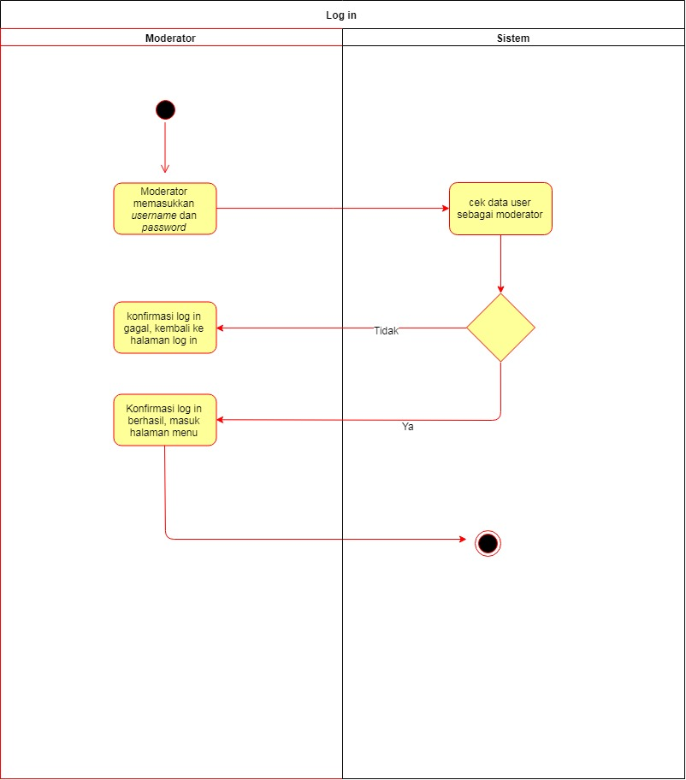

Gambar 3. *Activity diagram log in user*

**Berikut merupakan activity diagram dari actor admin:**

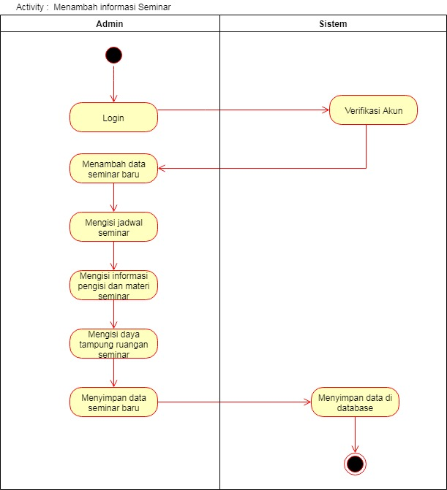

Gambar 4. *Activity diagram* Menambahkan Data Seminar

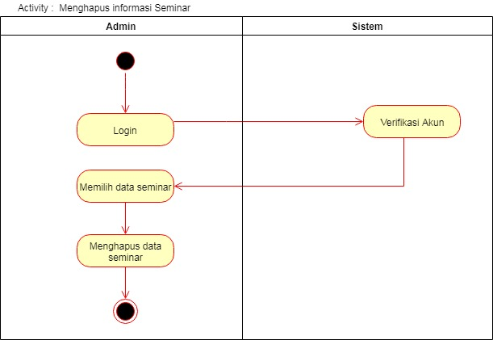

Gambar 5. *Activity diagram* Menghaous Data Seminar

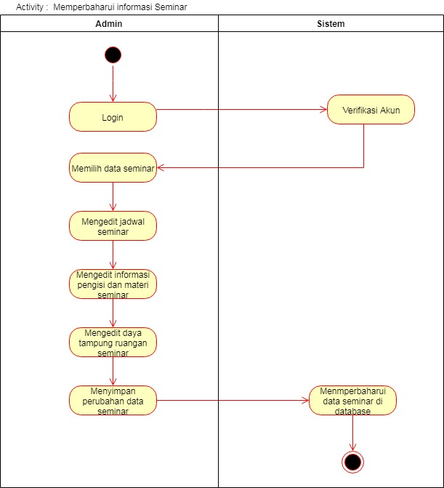

Gambar 6. *Activity diagram Update* Data Seminar

**Berikut merupakan *activity diagram* dari actor mahasiswa**

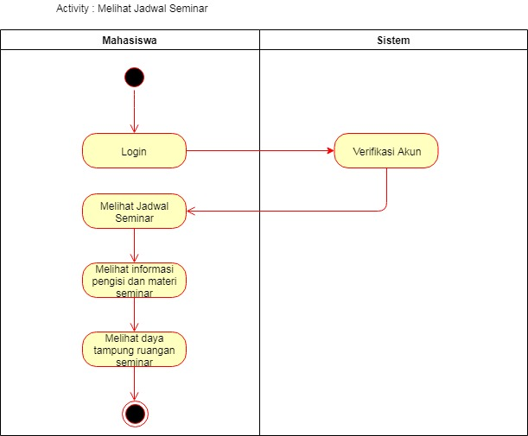

Gambar 7. *Activity diagram* Melihat Data Seminar

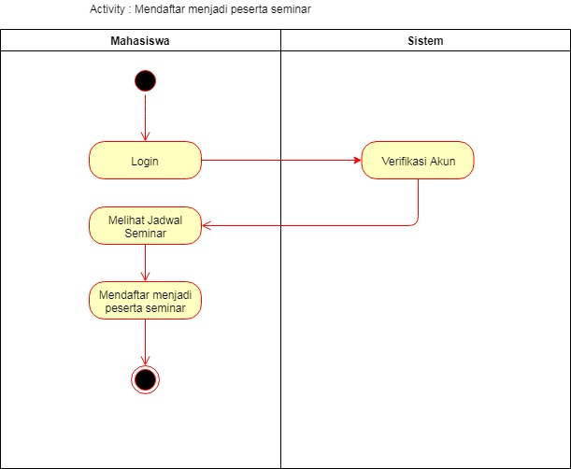

Gambar 7. *Activity diagram* Mendaftar Menjadi Peserta Seminar

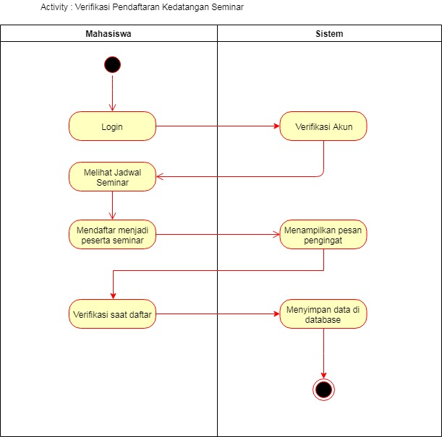

Gambar 7. *Activity diagram* Verifikasi Kedatangan Seminar

**Berikut merupakan *Activity Diagram* dari Aktor Moderator**

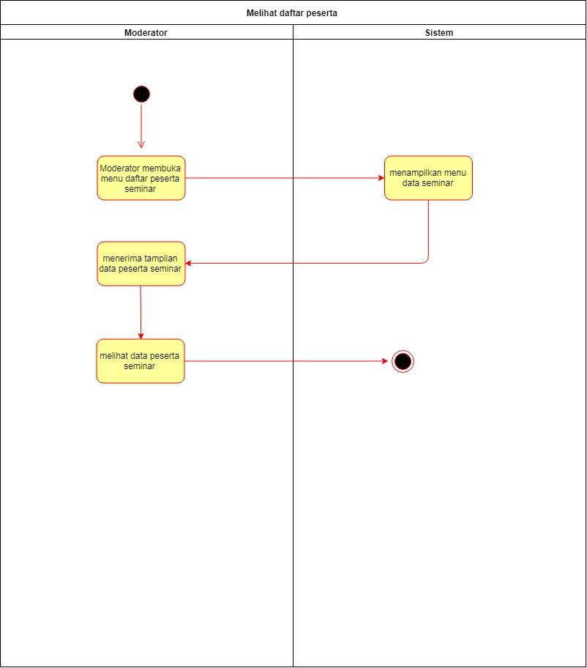

Gambar 8. *Activity diagram* Melihat Daftar Peserta Seminar

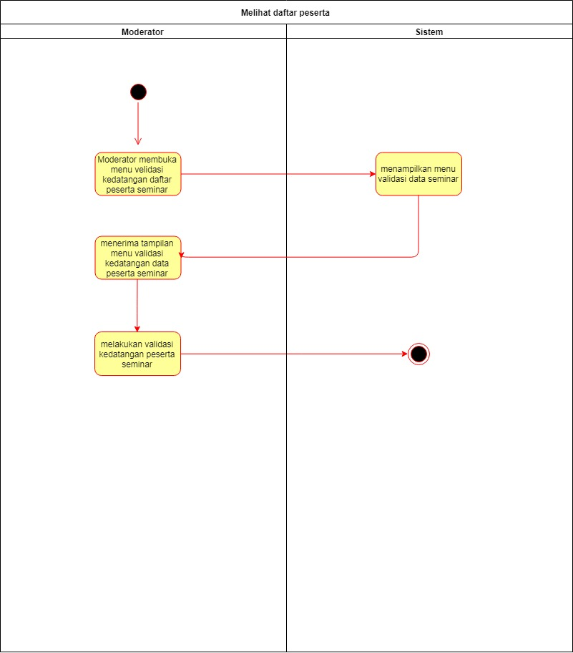

Gambar 9. *Activity diagram* Melakukan Validasi Kedatangan Peserta

**2.6 Sequence Diagram**

Sequence diagram menurut Munawar (2005 : 187) adalah grafik dua dimensi dimana obyek ditunjukkan dalam dimensi horizontal, sedangkan lifeline ditunjukkan dalam dimensi vertikal.

**2. 6.1 *Sequence Diagram* dari Aktor Admin**

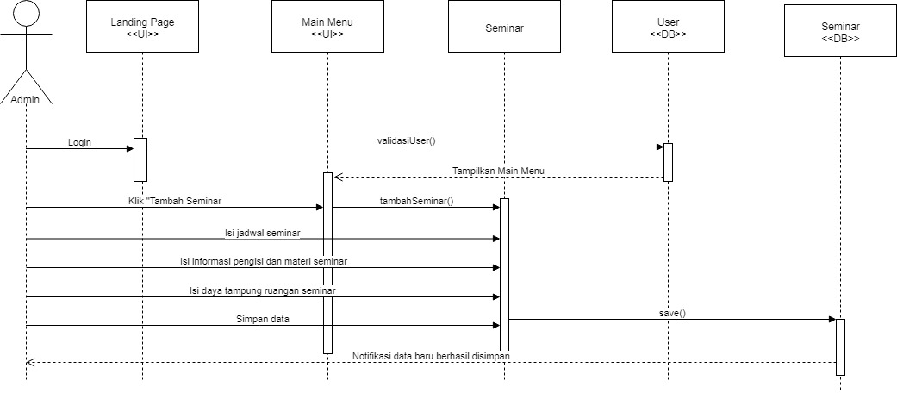

Gambar 10. *Sequence Diagram* Tambah Data Seminar

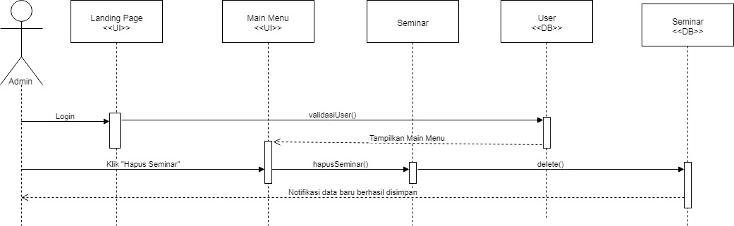

Gambar 11. *Sequence diagram* Hapus Data Seminar

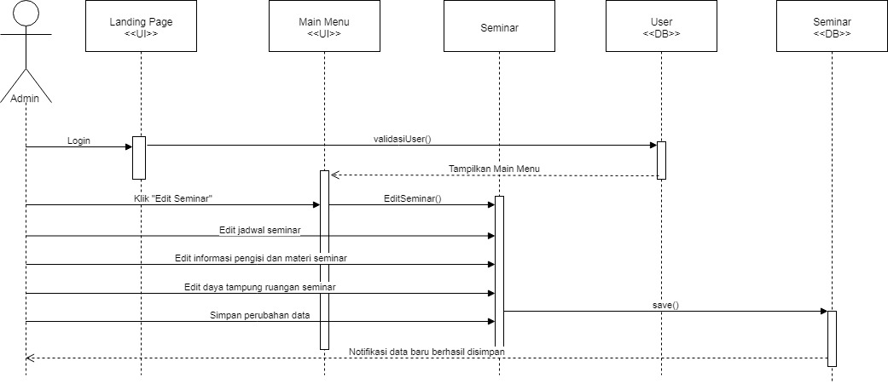

Gambar 12. *Sequence diagram* Update Jadwal Seminar

**2.6.2 *Sequence Diagram* dari Actor Mahasiswa**

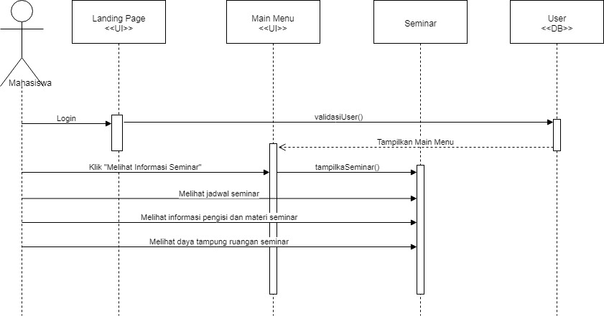

Gambar 13. *Sequence diagram* Melihat Jadwal Seminar

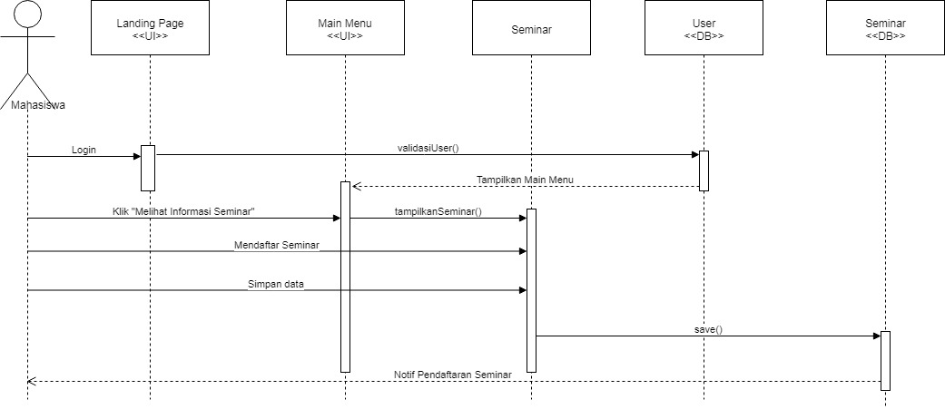

Gambar 14. *Sequence diagram* Mendaftar jadi Peserta Seminar

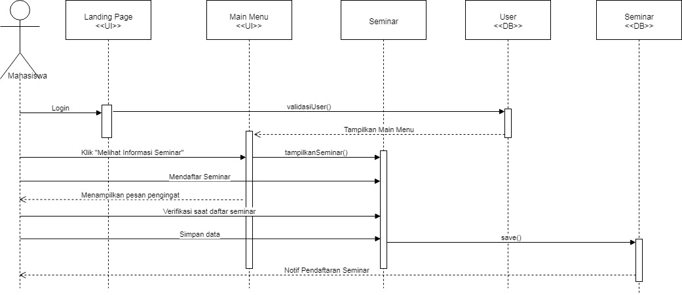

Gambar 15. *Sequence diagram* Verifikasi Kedatangan Seminar

**2.6.3 *Sequence diagram* dari Actor Moderator**

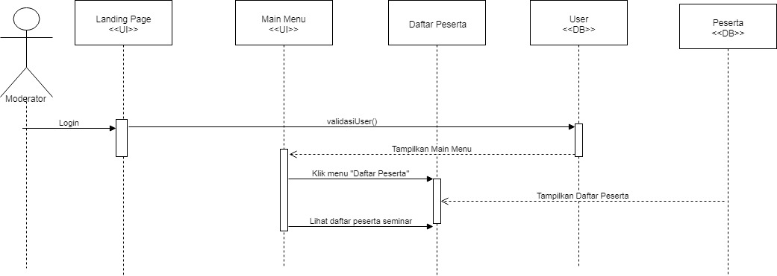

Gambar 16. *Sequence diagram* Melihat Peserta Seminar

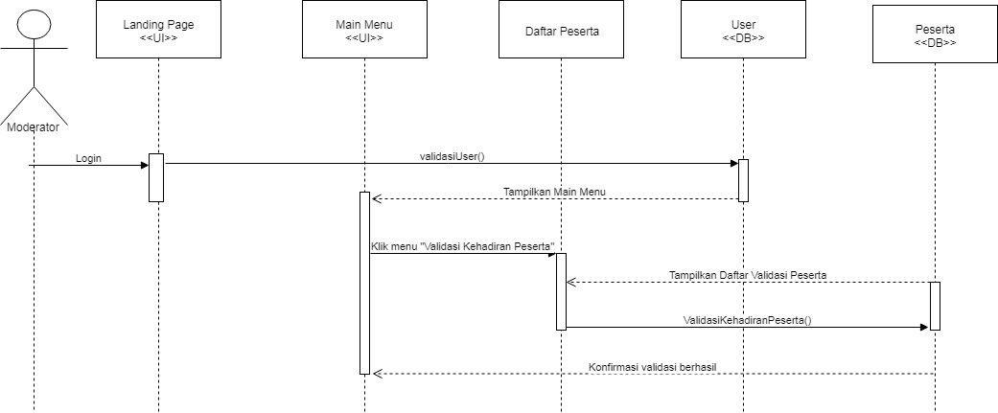

Gambar 17. *Sequence diagram* Validasi Kedatangan Seminar